Project Design Phase-II

**Technology Architecture**

|  |  |
| --- | --- |
| **Team ID** | **PNT2022TMID31303** |
| **Project Name** | **AI-powered Nutrition Analyzer for Fitness Enthusiasts** |
| **Batch ID** | **B2-2M4E** |

**Technical Stack:**

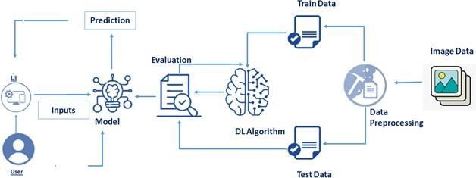

|  |  |  |  |
| --- | --- | --- | --- |
| **S.No** | **Component** | **Description** | **Technology** |
| 1. | User interface | How client connects with application for example: Web UI, Portable Application, Chatbot and so on. | HTML, CSS, JavaScript / Angular Js  / React Js etc. |
| 2. | Application Logic-1 | Rationale for a cycle in the application. | Java / Python |
| 3. | Application Logic-2 | Rationale for a cycle in the application. | IBM Watson STT service |
| 4. | Application Logic-3 | Rationale for a cycle in the application. | IBM Watson Assistant |
| 5. | Database | Data type, Configurations etc. | MySQL, NoSQL, etc. |
| 6. | Cloud Database | Data set help on Cloud. | IBM DB2,IBM Cloudant etc. |
| 7. | File Storage | Document capacity prerequisites. | IBM Block Stockpiling or other  Stockpiling administration or Neighborhood File system. |

|  |  |  |  |
| --- | --- | --- | --- |
| 8. | External AP-1 | Motivation behind Outside Programming interface utilized in the application. | IBM Weather API, etc. |
| 9. | External API-2 | Motivation behind Outside Programming interface utilized in the application. | Aadhar API, etc. |
| 10. | Machine Learning Model | Reason for Machine Learning Model. | Object Acknowledgment Model, and so on. |
| 11. | Infrastructure(Server/Cloud) | Application Sending on Neighbourhood Framework/Cloud  Nearby Server Setup: Cloud Server Design : | Neighborhood, Cloud Foundry, Kubernetes, and so on. |

Table-2: Application Characteristics:

|  |  |  |  |
| --- | --- | --- | --- |
| **S.No** | **Characteristics** | **Description** | **Technology** |
| 1. | Open-Source Systems | List the open-source systems utilized. | Innovation of open source system. |
| 2. | Security Executions | List all the security/access controls carried out, utilization of firewalls and so forth. | For example SHA-256, Encryptions , IAM controls, OWASP etc. |
| 3. | Versatile Engineering | Legitimize the versatility of use (3  - level, Miniature administrations) | Technology used |
| 4. | Availability | Legitimize the accessibility of utilization (e.g. use of load balancers, distributed servers etc.) | Technology used |
| 5. | Performance | Plan thought for the exhibition of the application (number of requests per sec, use of Cache, use of CDN’s) etc. | Technology used |

References:

<https://c4model.com/>

<https://developer.ibm.com/patterns/online-order-processing-system-during-pandemic/> <https://www.ibm.com/cloud/architecture>

<https://aws.amazon.com/architecture>

[https://medium.com/the-internal-startup/how-to-draw-useful-technical-architecture-](https://medium.com/the-internal-startup/how-to-draw-useful-technical-architecture-diagrams-2d20c9fda90d) [diagrams-2d20c9fda90d](https://medium.com/the-internal-startup/how-to-draw-useful-technical-architecture-diagrams-2d20c9fda90d)